Implementing Web Application

Create IBM DB2 And Connect With Python

|  |  |
| --- | --- |
| Team ID | PNT2022TMID50454 |
| Project Name | Cloud Computing – Nutrition Assistant |

IBM DB2:

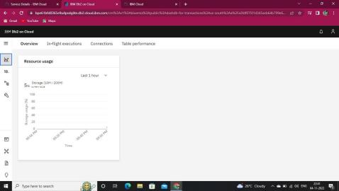

DB2 WITH PYTHON:

